**Project Planning Phase**

**Project Planning Template (Product Backlog, Sprint Planning, Stories, Story points)**

| Date | 26 June 2025 |
| --- | --- |
| Team ID |  |
| Project Name | LAPTOP REQUEST CATALOG ITEM |
| Maximum Marks | 5 Marks |

**Product Backlog, Sprint Schedule, and Estimation (4 Marks)**

| **Sprint** | **Functional Requirement (Epic)** | **User Story Number** | **User Story / Task** | **Story Points** | **Priority** | **Team Members** |
| --- | --- | --- | --- | --- | --- | --- |
| Sprint-1 | Laptop Request Form | USN-1 | As an employee, I can access a laptop request form in ServiceNow with guided fields. | 3 | High | Developer, UX |
| Sprint-1 | Laptop Request Form | USN-2 | As an employee, I see role-based laptop recommendations based on my job title. | 2 | High | Developer |
| Sprint-2 | Form Dynamics | USN-3 | As an employee, I see dynamic fields that change based on my selections (via UI Policies) | 3 | Medium | Developer, Tester |
| Sprint-1 | Form Functionality | USN-4 | As an employee, I can reset the form to correct errors before submission. | 1 | Medium | Developer |
| Sprint-1 | Approval Workflow | USN-5 | As a manager, I can approve or reject laptop requests with comments. | 2 | High | Developer, IT |
| Sprint-3 | Status Tracking | USN-6 | As an employee, I can see the real-time status of my laptop request. | 2 | Medium | Developer, UX |
| Sprint-3 | Integration | USN-7 | As IT staff, I can see laptop availability from CMDB during request processing | 3 | Low | Developer, IT |
| Sprint-2 | Notifications | USN-8 | As an employee, I receive email updates on request approval or rejection. | 1 | High | Developer |

**Developer/ Tester = Y.Lowshik Teja IT= B.Praveen  
Ux = R. Hemachand UX/Developer = Mokshagna Sai**

**Project Tracker, Velocity & Burndown Chart: (4 Marks)**

| **Sprint** | **Total Story Points** | **Duration** | **Sprint Start Date** | **Sprint End Date (Planned)** | **Story Points Completed (as on Planned End Date)** | **Sprint Release Date (Actual)** |
| --- | --- | --- | --- | --- | --- | --- |
| Sprint-1 | 7 | 4 Days | 13 Jun 2025 | 16 Jun 2025 | 7 | 16 Jun 2025 |
| Sprint-2 | 5 | 4 Days | 17 Jun 2025 | 20 Jun 2025 | 5 | 20 Jun 2025 |
| Sprint-3 | 5 | 5 Days | 21 Jun 2025 | 25 Jun 2025 | 5 | 25 Jun 2025 |

**Velocity:**

**Sprint-1:** Completed 7 story points in 4 days, with a higher velocity due to focused work on core functionalities.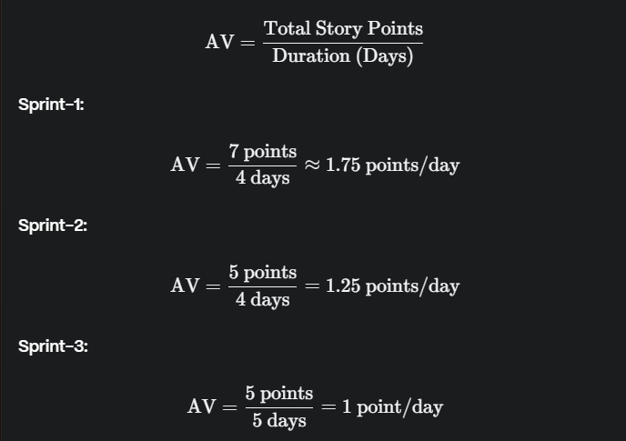

**Sprint-2:** Completed 5 story points in 4 days, slightly lower velocity due to more complex tasks.

**Sprint-3:** Completed 5 story points in 5 days, the lowest velocity due to additional time required for testing and integrations.